Honeywell Genesis 7580g
Tastatur-Modus
05.06.2024
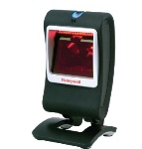
Resetting the Factory Defaults: Activate Defaults
Presentation Aimer Mode: Interlaced
Cellular Telephone Reading Mode: On
Program Keyboard Country: Germany
Dead Key Thru Alt+Numpad Sequence: Windows System Code Page
Prefix: STX
Suffix: ETX
Keyboard Modifiers: Windows Mode Control + X


DEFALT;PDCAIM2;KBDCTY4;KBDALT4;HSTACH18;HSTDCH20;DECCEL1;PREBK29902;SUFBK29903;KBDCAS2.

